100 Java Programs
Contents
Java Programs .............................................................................................................................................................................. 1
- Simple Java Program. ....................................................................................................................................................... 4
- Print Integer in java ............................................................................................................................................................ 4
- Command Line Argument ................................................................................................................................................ 4
- How to get Using input using Scanner Program in java ........................................................................................ 5
- How to convert Fahrenheit to Celsius Program in java ....................................................................................... 5
- How to swap 2 no using 3rd variable Program in java ............................................................................................ 6
- How to swap 2 no without using 3rd variable Program in java ............................................................................. 6
- How to add two number Program in java ................................................................................................................... 7
- Find Largest no in java Program ................................................................................................................................... 8
- If Else clause in java ..................................................................................................................................................... 8
- If Else clause in java- Program 2 ............................................................................................................................... 9
- Nested If Else clause in java ....................................................................................................................................... 9
- How to check Odd and Even Number in java. ...................................................................................................... 10
- Find factorial for given no Program in Java ......................................................................................................... 10
- How to complete 2 string in Java program .......................................................................................................... 11
- Simple For Loop Program in Java ......................................................................................................................... 12
- Print Star console using Loop ................................................................................................................................. 12
- Print Star console using Loop ................................................................................................................................. 13
- While loop Program in java ....................................................................................................................................... 13
- Print Reverse number in java program ................................................................................................................. 14
- While loop using break Program in java .............................................................................................................. 14
- While loop using break and continue Program in java ...................................................................................... 15
- Print all alphabet using for loop Program in java................................................................................................ 15
- Enhance loop in java Program ................................................................................................................................ 16
- Print Multiplication table Program in java ............................................................................................................ 16
- Print prime no Program in java ............................................................................................................................... 17
- Check no is Armstrong or not in java Program ................................................................................................. 18
- Print Floyd’s Triangle in java Program ................................................................................................................ 19
- Find All substring of string in java Program ........................................................................................................ 19
Automation Proficient
- Print reverse string in java Program ..................................................................................................................... 20
- Check Given No is palindrome or Not in java Program .................................................................................... 21
- How to add two matrix in java Program ................................................................................................................. 22
- How to multiply two matrix in java Program......................................................................................................... 23
- How to get transpose of matrix in java Program ................................................................................................ 24
- How to compare 2 string in java Program ............................................................................................................ 25
- How to string width with specific char in java Program ................................................................................... 25
- How to use indesOf() in java Program .................................................................................................................. 25
- How to replace string with another string in java Program ............................................................................. 26
- How to split string in java Program ........................................................................................................................ 26
- How to remove space in string both end in java Program................................................................ ................ 26
- How to convert all char in string lower case in java Program ......................................................................... 26
- How to create method in java Program ................................................................................................................ 27
- Find Length, Concatenate and Replace String in Java Program ................................................................... 27
- How Static block working in java Program ........................................................................................................... 28
- Difference between Static and Instance method working in java Program ................................................. 28
- How to create Multiple class in java Program ..................................................................................................... 29
- How to create constructor in java Program ......................................................................................................... 29
- How to create constructor overloading in java Program ................................................................................. 30
- Exception Handling java Program........................................................................................................................... 30
- How to throw exception in java Program ............................................................................................................. 31
- Advantage of Finally in Exception Handling java Program ............................................................................. 31
- How to create Interface in java Program .............................................................................................................. 32
- How to print date and time in java Program ........................................................................................................ 32
- How to SQL Date in java Program................................ .......................................................................................... 33
- How to Date format in java Program .................................................................................................................... 33
- How to Generate random number in java Program ........................................................................................... 34
- How perform garbage collection in java Program ............................................................................................. 34
- How to get own IP Address in java Program................................ ....................................................................... 34
- How to open notepad in java Program.................................................................................................................. 35
- Leaner search Program in java ............................................................................................................................... 35
- Binary search Program in java ................................................................................................................................ 36
- Bubble sort Program in java .................................................................................................................................... 37
- How to connect Database using java Program .................................................................................................... 37
- How to insert data in table using JDBC in java Program ................................................................................ 38
- How to insert image using JDBC in java Program ............................................................................................ 38
- How to execute Procedure in JDBC in java Program....................................................................................... 39 Automation Proficient
- How to check Regular expression in java Program .......................................................................................... 39
- How to create Multithreading program in java ..................................................................................................... 39
- How to join thread in java program ....................................................................................................................... 40
- How to write data in text file using java program ............................................................................................... 40
- How to read data from text file using java program .......................................................................................... 40
- How to get URL of site using java Programs ....................................................................................................... 41
- How to get IP address from site URL using java program ................................................................................ 41
- How to create AWT program in java ....................................................................................................................... 41
- How to add lable in AWT program in java ............................................................................................................ 42
- How to add text area program in java .................................................................................................................... 42
- How to dropdown in AWT program in java ........................................................................................................... 42
- How to create Swing program in java ................................................................................................................... 43
- How to add checkbox in Swing program in java ................................................................................................. 43
- How to convert string to integer in java program .............................................................................................. 44
- How to convert integer to string in java program .............................................................................................. 44
- How to convert string to long in java ..................................................................................................................... 44
- How to convert string to float in java ..................................................................................................................... 44
- How to convert string to double in java program................................................................................................ 44
- How to convert string to date in java program ................................................................................................... 45
- Create ArrayList program in java ......................................................................................................................... 45
- How to create LinkedList program in java ............................................................................................................ 46
- How to ArrayList using list interface program in java ....................................................................................... 46
- How to create Hashset program in java ................................................................................................................. 47
- How to create LinkedHashSet program in java ................................................................................................... 47
- How to create TreeSet program in java.................................................................................................................. 48
- How to create PriorityQueue program in java ...................................................................................................... 48
- How to create HashMap using map interface program in java ........................................................................ 49
- How to create LinkedHashMap program in java ................................................................................................. 49
- How to create TreeMap program in java ................................................................................................................ 49
- How to create Hashtable program in java ............................................................................................................. 50
- How to create Array program in java ...................................................................................................................... 50
- How to create Multidimensional array program in java ..................................................................................... 50
- How to create Find Factorial No using Recursion Program in java .............................................................. 51
- How to create Method Overriding program in java ............................................................................................. 51

Automation Pro f icient
1. Simple Java Program
class HelloWorld
{
public static void main(String args[])
{
System.out.println("Hello World by Technolamror");
}
}

2. Print Integer in java
class
Integers
{

public

static

void
main
(
String
[]
arguments
)

{

int
c
;

//declaring a variable

/* Using for loop to repeat instruction execution */

for

(
c
=

1
;
c
<=

10
;
c
++
)

{

System
.
out
.
println
(
c
)
;

}

}

}

3. Command Line Argument in java
class Arguments {
public static void main(String[] args) { for (String t: args) { System.out.println(t);
}
} }

Automation Proficient

4. How to get Using input using Scanner Program in java
import java.util.Scanner;
class GetInputFromUser
{

public

static

void
main
(
String
args
[])

{

int
a
;

float
b
;

String
s
;

Scanner in
=

new
Scanner
(
System
.
in
)
;

System
.
out
.
println
(
"Enter a string"
)
;

s
=
in.
nextLine
()
;

System
.
out
.
println
(
"You entered string "
+
s
)
;

System
.
out
.
println
(
"Enter an integer"
)
;

a
=
in.
nextInt
()
;

System
.
out
.
println
(
"You entered integer "
+
a
)
;

System
.
out
.
println
(
"Enter a float"
)
;

b
=
in.
nextFloat
()
;

System
.
out
.
println
(
"You entered float "
+
b
)
;

}

}

5. How to convert Fahrenheit to Celsius Program in java
import java.util.*;

class FahrenheitToCelsius { public static void main(String[] args) { float temperatue;
Scanner in = new Scanner(System.in);

System.out.println("Enter temperatue in Fahrenheit"); temperatue = in.nextInt();

temperatue = ((temperatue - 32)*5)/9;

System.out.println("Temperatue in Celsius = " + temperatue); }
}

Automation Pro ficient

6. How to swap 2 no using 3rd variable Program in java
import

java.util.Scanner
;

class
SwapNumbers
{

public

static

void
main
(
String
args
[])

{

int
x, y, temp
;

System
.
out
.
println
(
"Enter x and y"
)
;

Scanner in
=

new
Scanner
(
System
.
in
)
;

x
=
in.
nextInt
()
;

y
=
in.
nextInt
()
;

System
.
out
.
println
(
"Before Swapping
\n
x = "
+
x
+
"
\n
y = "
+
y
)
;

temp
=
x
;

x
=
y
;

y
=
temp
;

System
.
out
.
println
(
"After Swapping
\n
x = "
+
x
+
"
\n
y = "
+
y
)
;

}

}

7. How to swap 2 no without using 3rd variable Program in java
import java.util.Scanner;
class SwapNumbers
{
public static void main(String args[])
{ int x, y;
System.out.println("Enter x and y");
Scanner in = new Scanner(System.in);
x = in.nextInt(); y = in.nextInt();

System.out.println("Before Swapping\nx = "+x+"\ny = "+y);

Automation Pro ficient
x = x + y; y = x - y; x = x - y;

System.out.println("After Swapping\nx = "+x+"\ny = "+y);
}
}

8. How to add two number Program in java

import java.util.Scanner;

System.out.println("Enter second large number"); number2 = in.nextLine();
class
AddNumbers
{

public

static

void
main
(
String
args
[])

{

int
x, y, z
;

System
.
out
.
println
(
"Enter two integers to calculate their sum "
)
;

Scanner in
=

new
Scanner
(
System
.
in
)
;

x
=
in.
nextInt
()
;

y
=
in.
nextInt
()
;

z
=
x
+
y
;

System
.
out
.
println
(
"Sum of entered integers = "
+
z
)
;

}

}
//For Large Number
import

java.util.Scanner
;

import

java.math.BigInteger
;

class
AddingLargeNumbers
{

public

static

void
main
(
String
[]
args
)

{

String
number1, number2
;

Scanner in
=

new
Scanner
(
System
.
in
)
;

System
.
out
.
println
(
"Enter first large number"
)
;

number1
=
in.
nextLine
()
;

BigInteger first = new BigInteger(number1);
BigInteger second = new BigInteger(number2);
BigInteger sum;

sum = first.add(second);

System.out.println("Result of addition = " + sum);
}

Automation Prof icient
}

9. Find Largest no in java Program
import java.util.Scanner;
class LargestOfThreeNumbers
{
public static void main(String args[])
{ int x, y, z;
System.out.println("Enter three integers ");
Scanner in = new Scanner(System.in);
x = in.nextInt(); y = in.nextInt(); z = in.nextInt();

if ( x > y && x > z )
System.out.println("First number is largest."); else if ( y > x && y > z )
System.out.println("Second number is largest."); else if ( z > x && z > y )
System.out.println("Third number is largest."); else
System.out.println("Entered numbers are not distinct.");
}
}

10. If Else clause in java
class Condition {
public static void main(String[] args) { boolean learning = true;

if (learning) {
System.out.println("Java programmer");
} else {
System.out.println("What are you doing here?");
}
}
}

Automation Prof icient

11. If Else clause in java- Program 2
// If else in Java code

import

java.util.Scanner
;

class
IfElse
{

public

static

void
main
(
String
[]
args
)

{

int
marksObtained, passingMarks
;

passingMarks
=

40
;

Scanner input
=

new
Scanner
(
System
.
in
)
;

System
.
out
.
println
(
"Input marks scored by you"
)
;

marksObtained
=
input.
nextInt
()
;

if

(
marksObtained
>=
passingMarks
)

{

System
.
out
.
println
(
"You passed the exam."
)
;

}

else

{

System
.
out
.
println
(
"Unfortunately you failed to pass the exam."
)
;

}

}

}

12. Nested If Else clause in java
import

java.util.Scanner
;

class
NestedIfElse
{

public

static

void
main
(
String
[]
args
)

{

int
marksObtained, passingMarks
;

char
grade
;

passingMarks
=

40
;

Scanner input
=

new
Scanner
(
System
.
in
)
;

System.out.println("Input marks scored by you");

marksObtained = input.nextInt();
if (marksObtained >= passingMarks) {

if (marksObtained > 90) grade = 'A';

else if (marksObtained > 75) grade = 'B'; else if (marksObtained > 60) grade = 'C'; else
grade = 'D';

System.out.println("You passed the exam and your grade is " + grade);
} else { grade = 'F';
System.out.println("You failed and your grade is " + grade);
}
}
}

13. How to check Odd and Even Number in java.
import

java.util.Scanner
;

class
OddOrEven
{

public

static

void
main
(
String
args
[])

{

int
x
;

System
.
out
.
println
(
"Enter an integer to check if it is odd or even "
)
;

Scanner in
=

new
Scanner
(
System
.
in
)
;

x
=
in.
nextInt
()
;

if

(
x
%

2

==

0

)

System
.
out
.
println
(
"You entered an even number."
)
;

else

System
.
out
.
println
(
"You entered an odd number."
)
;

}

}

14. Find factorial for given no Program in Java
import java.util.Scanner;
class Factorial
{
public static void main(String args[])
{
int n, c, fact = 1;

System.out.println("Enter an integer to calculate it's factorial");
Scanner in = new Scanner(System.in);

n = in.nextInt();

if ( n < 0 )
System.out.println("Number should be non-negative."); else
{
for ( c = 1 ; c <= n ; c++ ) fact = fact*c;

System.out.println("Factorial of "+n+" is = "+fact);
}

}

}

//
Calculate factorial for large No

import

java.util.Scanner
;

import

java.math.BigInteger
;

class
BigFactorial
{

public

static

void
main
(
String
args
[])

{

int
n, c
;

BigInteger
inc
=

new

BigInteger
(
"1"
)
;

BigInteger
fact
=

new

BigInteger
(
"1"
)
;

Scanner input
=

new
Scanner
(
System
.
in
)
;

System
.
out
.
println
(
"Input an integer"
)
;

n
=
input.
nextInt
()
;

for

(
c
=

1
;
c
<=
n
;
c
++
)

{

fact
=
fact.
multiply
(
inc
)
;

inc
=
inc.
add
(
BigInteger
.
ONE
)
;

}

System
.
out
.
println
(
n
+

"! = "

+
fact
)
;

}

}

15. How to complete 2 string in Java program
import java.util.Scanner;
class CompareStrings
{
public static void main(String args[])
{
String s1, s2;
Scanner in = new Scanner(System.in);

System.out.println("Enter the first string"); s1 = in.nextLine();

System.out.println("Enter the second string"); s2 = in.nextLine();

if ( s1.compareTo(s2) > 0 )
System.out.println("First string is greater than second."); else if ( s1.compareTo(s2) < 0 )
System.out.println("First string is smaller than second."); else
System.out.println("Both strings are equal.");
}
}

16. Simple For Loop Program in Java
//Java for loop program

class
ForLoop
{

public

static

void
main
(
String
[]
args
)

{

int
c
;

for

(
c
=

1
;
c
<=

10
;
c
++
)

{

System
.
out
.
println
(
c
)
;

}

}

}

17. Print Star console using Loop
class Stars {
public static void main(String[] args) {

int
row, numberOfStars
;

for

(
row
=

1
;
row
<=

10
;
row
++
)

{

for
(
numberOfStars
=

1
;
numberOfStars
<=
row
;
numberOfStars
++
)

{

System
.
out
.
print
(
"*"
)
;

}

System
.
out
.
println
()
;

// Go to next line

}

}

}

Automation Prof icient
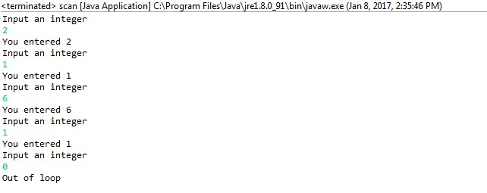

18. Print Star console using Loop

class
Stars
{

public

static

void
main
(
String
[]
args
)

{

int
row, numberOfStars
;

for

(
row
=

1
;
row
<=

10
;
row
++
)

{

for
(
numberOfStars
=

1
;
numberOfStars
<=
row
;
numberOfStars
++
)

{

System
.
out
.
print
(
"*"
)
;

}

System
.
out
.
println
()
;

// Go to next line

}

}

}

19
.
While loop
Program in java
import

java.util.Scanner
;

class WhileLoop {
public static void main(String[] args) { int n;

Scanner input = new Scanner(System.in); System.out.println("Input an integer");
while ((n = input.nextInt()) != 0) { System.out.println("You entered " + n);
System.out.println("Input an integer");
}

System.out.println("Out of loop");
}

Automation Pro f icient
}

20. Print Reverse number in java program
import java.util.Scanner;

class
ReverseNumber
{

public

static

void
main
(
String
args
[])

{

int
n, reverse
=

0
;

System
.
out
.
println
(
"Enter the number to reverse"
)
;

Scanner in
=

new
Scanner
(
System
.
in
)
;

n
=
in.
nextInt
()
;

while
(
n
!=

0

)

{

reverse
=
reverse
*

10
;

reverse
=
reverse
+
n
%
10
;

n
=
n
/
10
;

}

System
.
out
.
println
(
"Reverse of entered number is "
+
reverse
)
;

}

}

21. While loop using break Program in java
import

java.util.Scanner
;

class
BreakWhileLoop
{

public

static

void
main
(
String
[]
args
)

{

int
n
;

Scanner input
=

new
Scanner
(
System
.
in
)
;

while

(
true
)

{

System
.
out
.
println
(
"Input an integer"
)
;

n
=
input.
nextInt
()
;

if (n == 0) { break;
}
System.out.println("You entered " + n);
}
}
}

Automation Pro ficient

22. While loop using break and continue Program in java
import

java.util.Scanner
;

class
BreakContinueWhileLoop
{

public

static

void
main
(
String
[]
args
)

{

int
n
;

Scanner input
=

new
Scanner
(
System
.
in
)
;

while

(
true
)

{

System
.
out
.
println
(
"Input an integer"
)
;

n
=
input.
nextInt
()
;

if

(
n
!=

0
)

{

System
.
out
.
println
(
"You entered "

+
n
)
;

continue
;

}

else

{

break
;

}

}

}

}

23. Print all alphabet using for loop Program in java
class Alphabets
{
public static void main(String args[])
{ char ch;
for( ch = 'a' ; ch <= 'z' ; ch++ )
System.out.println(ch);
}
}

Automation Pro ficient

24. Enhance loop in java Program
class EnhancedForLoop {
public static void main(String[] args) {
int primes[] = { 2, 3, 5, 7, 11, 13, 17, 19, 23, 29};
for (int t: primes) { System.out.println(t);

}

}

}

//For String
class
EnhancedForLoop
{

public

static

void
main
(
String
[]
args
)

{

String
languages
[]

=

{

"C"
,
"C++"
,
"Java"
,
"Python"
,
"Ruby"
}
;

for

(
String
sample
:
languages
)

{

System
.
out
.
println
(
sample
)
;

}

}

}

25. Print Multiplication table Program in java
import

java.util.Scanner
;

class
MultiplicationTable
{

public

static

void
main
(
String
args
[])

{

int
n, c
;

System
.
out
.
println
(
"Enter an integer to print it's multiplication
table"
)
;

Scanner in
=

new
Scanner
(
System
.
in
)
;

n
=
in.
nextInt
()
;

System
.
out
.
println
(
"Multiplication table of "
+
n
+
" is :-"
)
;

for

(
c
=

1

;
c
<=

10

;
c
++

)

System
.
out
.
println
(
n
+
"*"
+
c
+
" = "
+
(
n
*
c
))
;

}

}

//For Any Number import java.util.Scanner;
class Tables
{
public static void main(String args[])
{
int a, b, c, d;

Automation Pro f icient

System.out.println("Enter range of numbers to print their multiplication table");
Scanner in = new Scanner(System.in);
a = in.nextInt(); b = in.nextInt();

for (c = a; c <= b; c++) {
System.out.println("Multiplication table of "+c);

for

(
d
=

1
;
d
<=

10
;
d
++
)

{

System
.
out
.
println
(
c
+
"*"
+
d
+
" = "
+
(
c
*
d
))
;

}

}

}

}

26. Print prime no Program in java
import

java.util.*
;

class
PrimeNumbers
{

public

static

void
main
(
String
args
[])

{

int
n, status
=

1
, num
=

3
;

Scanner in
=

new
Scanner
(
System
.
in
)
;

System
.
out
.
println
(
"Enter the number of prime numbers you want"
)
;

n
=
in.
nextInt
()
;

if

(
n
>=

1
)

{

System
.
out
.
println
(
"First "
+
n
+
" prime numbers are :-"
)
;

System
.
out
.
println
(
2
)
;

}

for

(

int
count
=

2

;
count
<=
n
;

)

{

for

(

int
j
=

2

;
j
<=

Math
.
sqrt
(
num
)

;
j
++

)

{

if

(
num
%
j
==

0

)

{

status
=

0
;

break;
} }
if ( status != 0 )
{
System.out.println(num); count++;
}

Automation Pro ficient
status = 1; num++;
}
}
}

27. Check no is Armstrong or not in java Program
import

java.util.Scanner
;

class
ArmstrongNumber
{

public

static

void
main
(
String
args
[])

{

int
n, sum
=

0
, temp, remainder, digits
=

0
;

Scanner in
=

new
Scanner
(
System
.
in
)
;

System
.
out
.
println
(
"Input a number to check if it is an Armstrong
number"
)
;

n
=
in.
nextInt
()
;

temp
=
n
;

// Count number of digits

while

(
temp
!=

0
)

{

digits
++
;

temp
=
temp
/
10
;

}

temp
=
n
;

while

(
temp
!=

0
)

{

remainder
=
temp
%
10
;

sum
=
sum
+
power
(
remainder, digits
)
;

temp
=
temp
/
10
;

}

if

(
n
==
sum
)

System
.
out
.
println
(
n
+

" is an Armstrong number."
)
;

else

System.out.println(n + " is not an Armstrong number.");
}
static int power(int n, int r) { int c, p = 1;
for (c = 1; c <= r; c++) p = p*n;

return p;

f icient
}
}

28. Print Floyd’s Triangle in java Program
import java.util.Scanner;

class
FloydTriangle
{

public

static

void
main
(
String
args
[])

{

int
n, num
=

1
, c, d
;

Scanner in
=

new
Scanner
(
System
.
in
)
;

System
.
out
.
println
(
"Enter the number of rows of floyd's triangle you
want"
)
;

n
=
in.
nextInt
()
;

System
.
out
.
println
(
"Floyd's triangle :-"
)
;

for

(
c
=

1

;
c
<=
n
;
c
++

)

{

for

(
d
=

1

;
d
<=
c
;
d
++

)

{

System
.
out
.
print
(
num
+
" "
)
;

num
++
;

}

System
.
out
.
println
()
;

}

}

}

29. Find All substring of string in java Program
import java.util.Scanner; class SubstringsOfAString
{
public static void main(String args[])
{
String string, sub; int i, c, length;

Scanner in = new Scanner(System.in);
System.out.println("Enter a string to print it's all substrings"); string = in.nextLine();
length = string.length();

Automation Pro f icient
System.out.println("Substrings of \""+string+"\" are :-");

for( c = 0 ; c < length ; c++ )
{
for( i = 1 ; i <= length - c ; i++ )
{
sub = string.substring(c, c+i);
System.out.println(sub);
}
}
}
}

30. Print reverse string in java Program
import java.util.*;

class
ReverseString
{

public

static

void
main
(
String
args
[])

{

String
original, reverse
=

""
;

Scanner in
=

new
Scanner
(
System
.
in
)
;

System
.
out
.
println
(
"Enter a string to reverse"
)
;

original
=
in.
nextLine
()
;

int
length
=
original.
length
()
;

for

(

int
i
=
length
-

1

;
i
>=

0

;
i
--

)

reverse
=
reverse
+
original.
charAt
(
i
)
;

System
.
out
.
println
(
"Reverse of entered string is: "
+
reverse
)
;

}

}

//Using Internal java Methog
class
InvertString
{

public

static

void
main
(
String
args
[])

{

StringBuffer
a
=

new

StringBuffer
(
"Java programming is fun"
)
;

System
.
out
.
println
(
a.
reverse
())
;

}

}

31. Check Given No is palindrome or Not in java Program
import java.util.*;
class Palindrome
{
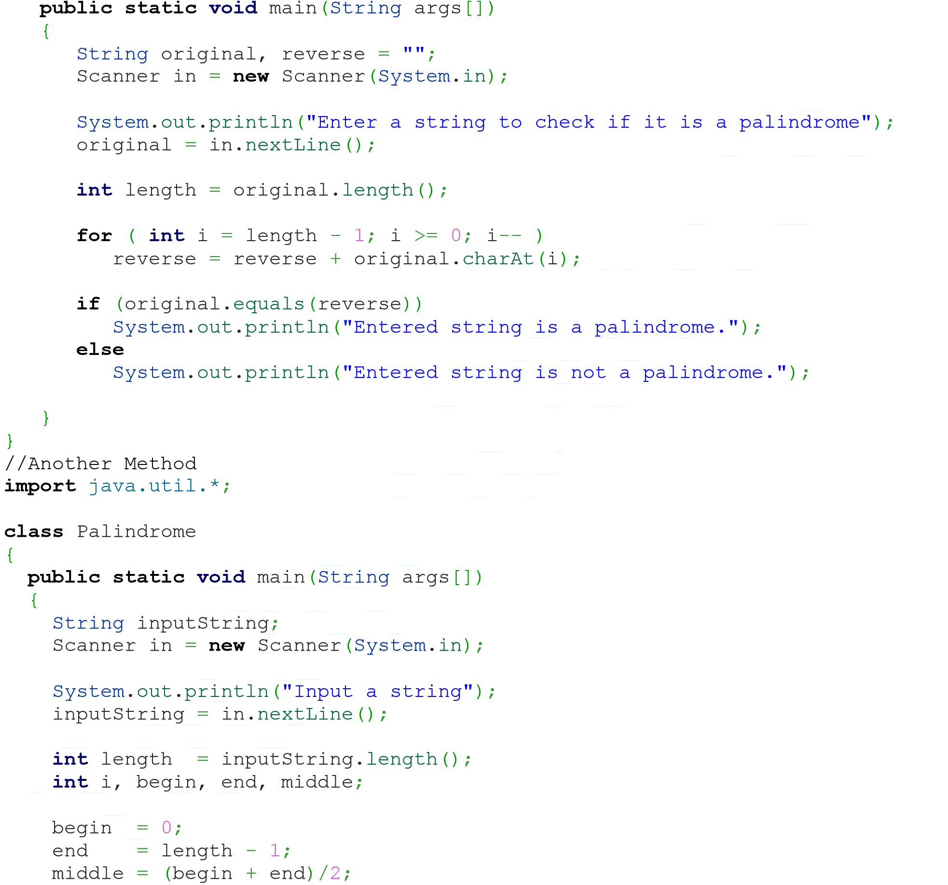

for (i = begin; i <= middle; i++) {
if (inputString.charAt(begin) == inputString.charAt(end)) { begin++; end--; } else { break;
}
}

if (i == middle + 1) {
System.out.println("Palindrome");
} else {
System.out.println("Not a palindrome");
}
}
}

32. How to add two matrix in java Program
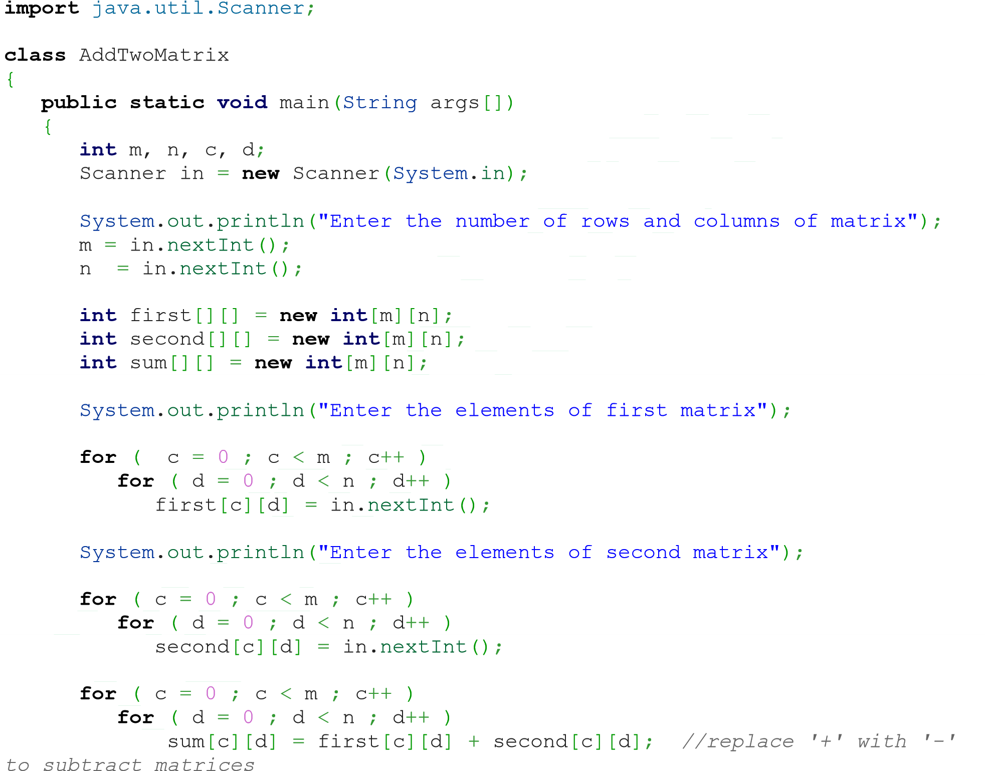

System.out.println("Sum of entered matrices:-");
for ( c = 0 ; c < m ; c++ )
{
for ( d = 0 ; d < n ; d++ ) System.out.print(sum[c][d]+"\t");

System.out.println();
}
}
}

33. How to multiply two matrix in java Program
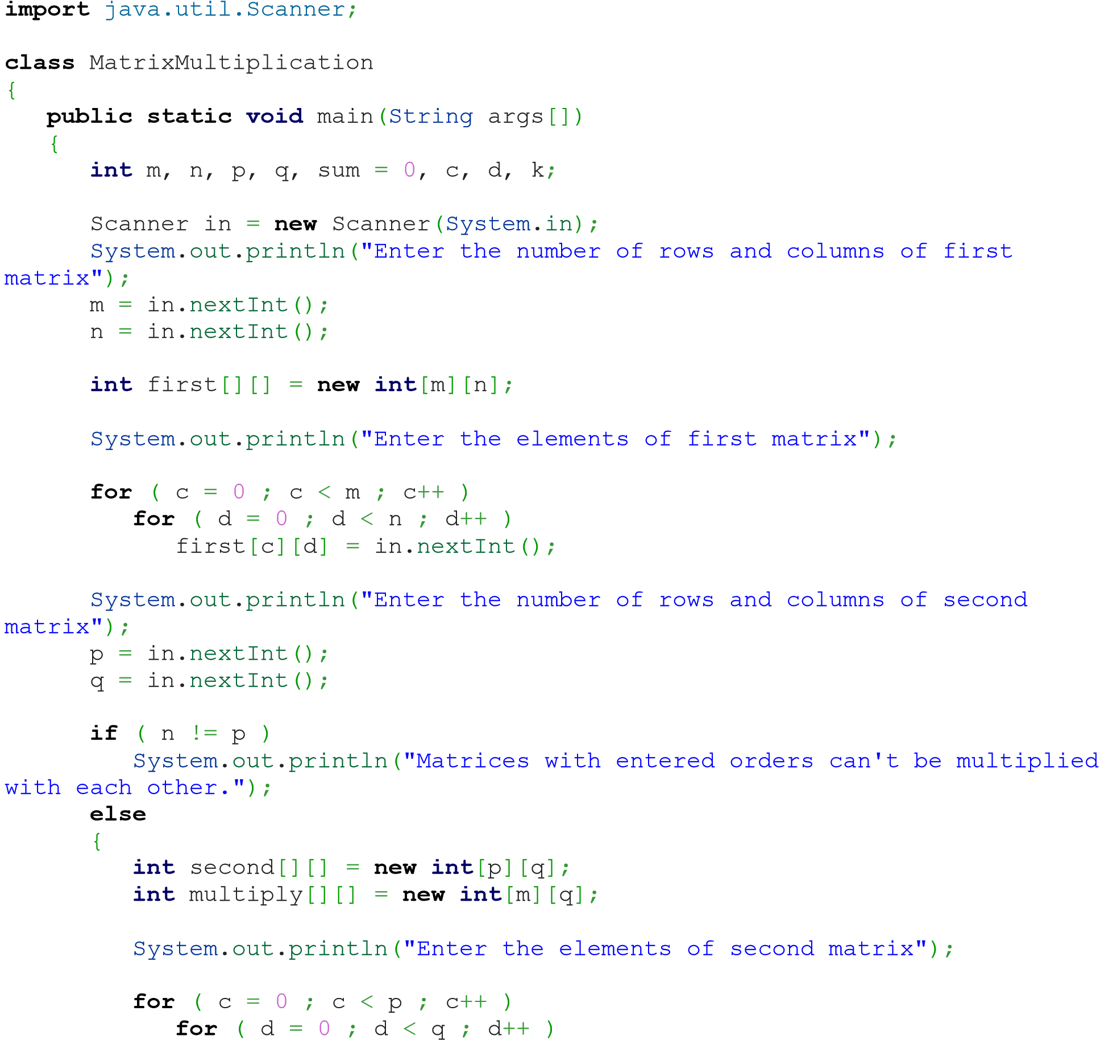
second[c][d] = in.nextInt();
for ( c = 0 ; c < m ; c++ )
{
for ( d = 0 ; d < q ; d++ )
{
for ( k = 0 ; k < p ; k++ )
{
sum = sum + first[c][k]*second[k][d];
}

multiply[c][d] = sum; sum = 0;
}
}

System.out.println("Product of entered matrices:-");

for

(
c
=

0

;
c
<
m
;
c
++

)

{

for

(
d
=

0

;
d
<
q
;
d
++

)

System
.
out
.
print
(
multiply
[
c
][
d
]
+
"
\t
"
)
;

System
.
out
.
print
(
"
\n
"
)
;

}

}

}

}

34. How to get transpose of matrix in java Program
import java.util.Scanner;

class
TransposeAMatrix
{

public

static

void
main
(
String
args
[])

{

int
m, n, c, d
;

Scanner in
=

new
Scanner
(
System
.
in
)
;

System
.
out
.
println
(
"Enter the number of rows and columns of matrix"
)
;

m
=
in.
nextInt
()
;

n
=
in.
nextInt
()
;

int
matrix
[][]

=

new

int
[
m
][
n
]
;

System
.
out
.
println
(
"Enter the elements of matrix"
)
;

for

(
c
=

0

;
c
<
m
;
c
++

)

for

(
d
=

0

;
d
<
n
;
d
++

)

matrix
[
c
][
d
]

=
in.
nextInt
()
;

int transpose[][] = new int[n][m];

for ( c = 0 ; c < m ; c++ )
{
for ( d = 0 ; d < n ; d++ ) transpose[d][c] = matrix[c][d]; }

System.out.println("Transpose of entered matrix:-");

for ( c = 0 ; c < n ; c++ )
{
for ( d = 0 ; d < m ; d++ )
System.out.print(transpose[c][d]+"\t");

System.out.print("\n");
}
}
}

35. How to compare 2 string in java Program
public class LastIndexOfExample{ public static void main(String args[]){
String s1="hello";
String s2="hello";
String s3="meklo";
String s4="hemlo";
System.out.println(s1.compareTo(s2));
System.out.println(s1.compareTo(s3));
System.out.println(s1.compareTo(s4)); }}

36. How to string width with specific char in java Program
class StringEndwith{
public static void main(String args[]){ String s1="java by TechnoLamror";
System.out.println(s1.endsWith("r")); //true
System.out.println(s1.endsWith("Lamror")); //true
System.out.println(s1.endsWith("lamror"));//false
}
}

37. How to use indesOf() in java Program
public class IndexOfExample{ public static void main(String args[]){
String s1="this is index of example";
//passing substring
int index1=s1.indexOf("is");//returns the index of is substring int index2=s1.indexOf("index");//returns the index of index substring
System.out.println(index1+" "+index2);//2 8

//passing substring with from index
int index3=s1.indexOf("is",4);//returns the index of is substring after 4th index
System.out.println(index3);//5 i.e. the index of another is

//passing char value
int index4=s1.indexOf('s');//returns the index of s char value
}} System.out.println(index4);//3

38. How to replace string with another string in java Program
public class ReplaceAllExample2{ public static void main(String args[]){
String s1="My name is Rajendra. My name is lamror. My name is Technolamror.";
String replaceString=s1.replaceAll("is","was");//replaces all occurrences of "is" to "was"
System.out.println(replaceString); }}

39. How to split string in java Program
public class SplitExample{
public static void main(String args[]){
String s1="java string split method by Technolamror";
String[] words=s1.split("\\s");//splits the string based on whitespace
//using java foreach loop to print elements of string array for(String w:words){ System.out.println(w);
}
}}

40. How to remove space in string both end in java Program
public class StringTrimExample{ public static void main(String args[]){
String s1=" hello string ";
System.out.println(s1+"Technolamror");//without trim()
System.out.println(s1.trim()+"Technolamror");//with trim() }}

41. How to convert all char in string lower case in java Program
public class StringLowerExample{ public static void main(String args[]){
String s1="TECHNOLAMROR by Rajendralamror HELLO stRIng";
String s1lower=s1.toLowerCase();

Automation Prof icient
}} System.out.println(s1lower);

42. How to create method in java Program
class Methods {

// Constructor method

Methods
()

{

System
.
out
.
println
(
"Constructor method is called when an object of it's
class is created"
)
;

}

// Main method where program execution begins

public

static

void
main
(
String
[]
args
)

{

staticMethod
()
;

Methods object
=

new
Methods
()
;

object.
nonStaticMethod
()
;

}

// Static method

static

void
staticMethod
()

{

System
.
out
.
println
(
"Static method can be called without creating
object"
)
;

}

// Non static method

void
nonStaticMethod
()

{

System
.
out
.
println
(
"Non static method must be called by creating an
object"
)
;

}

}

43. Find Length, Concatenate and Replace String in Java Program
class StringMethods
{
public static void main(String args[])
{ int n;
String s = "Java programming", t = "", u = "";
System.out.println(s);

// Find length of string

n = s.length();
System.out.println("Number of characters = " + n);

// Replace characters in string
t = s.replace("Java", "C++");
System.out.println(s);
System.out.println(t);

// Concatenating string with another string

u
=
s.
concat
(
" is fun"
)
;

System
.
out
.
println
(
s
)
;

System
.
out
.
println
(
u
)
;

}

}

44. How Static block working in java Program
class
StaticBlock
{

public

static

void
main
(
String
[]
args
)

{

System
.
out
.
println
(
"Main method is executed."
)
;

}

static

{

System
.
out
.
println
(
"Static block is executed before main method."
)
;

}

}
//Static Block
Application …. We need to open Program in speciif window

class
StaticBlock
{

public

static

void
main
(
String
[]
args
)

{

System
.
out
.
println
(
"You are using Windows_NT operating system."
)
;

}

static

{

String
os
=

System
.
getenv
(
"OS"
)
;

if

(
os.
equals
(
"Windows_NT"
)

!=

true
)

{

System
.
exit
(
1
)
;

}

}

}

45. Difference between Static and Instance method working in java Program
class Difference {
public static void main(String[] args) { display(); //calling without object

ficient
Difference t = new Difference();
t.show(); //calling using object
}
static void display() {
System.out.println("Programming is amazing.");
} void show(){
System.out.println("Java is awesome.");
}
}

46. How to create Multiple class in java Program
class Computer {
Computer() {
System.out.println("Constructor of Computer class."); }

void
computer_method
()

{

System
.
out
.
println
(
"Power gone! Shut down your PC soon..."
)
;

}

public

static

void
main
(
String
[]
args
)

{

Computer my
=

new
Computer
()
;

Laptop your
=

new
Laptop
()
;

my.
computer_method
()
;

your.
laptop_method
()
;

}

}

class
Laptop
{

Laptop
()

{

System
.
out
.
println
(
"Constructor of Laptop class."
)
;

}

void
laptop_method
()

{

System
.
out
.
println
(
"99% Battery available."
)
;

}

}

47. How to create constructor in java Program
class Programming {
//constructor method
Programming() {
System.out.println("Constructor method called.");
}

public static void main(String[] args) {
Programming object = new Programming(); //creating object
}
}

48. How to create constructor overloading in
java Program
class
Language
{

String
name
;

Language
()

{

System
.
out
.
println
(
"Constructor method called."
)
;

}

Language
(
String
t
)

{

name
=
t
;

}

public

static

void
main
(
String
[]
args
)

{

Language cpp
=

new
Language
()
;

Language java
=

new
Language
(
"Java"
)
;

cpp.
setName
(
"C++"
)
;

java.
getName
()
;

cpp.
getName
()
;

}

void
setName
(
String
t
)

{

name
=
t
;

}

void
getName
()

{

System
.
out
.
println
(
"Language name: "

+
name
)
;

}

}

49. Exception Handling java Program
class Division {
public static void main(String[] args) {
int a, b, result;

Scanner input = new Scanner(System.in);
System.out.println("Input two integers");

f icient
a = input.nextInt(); b = input.nextInt();

// try block
try {
result = a / b;
System.out.println("Result = " + result);
}

// catch block

catch

(
ArithmeticException
e
)

{

System
.
out
.
println
(
"Exception caught: Division by zero."
)
;

}

}

}

50. How to throw exception in java Program
public class TestThrow1{ static void validate(int age){ if(age<18)
throw new ArithmeticException("not valid"); else
System.out.println("welcome to vote on Technolamror");
}
public static void main(String args[]){ validate(13);
System.out.println("rest of the code...");
}
}

51. Advantage of Finally in Exception Handling java Program
class Allocate {
public static void main(String[] args) {
try {
long data[] = new long[1000000000];
}
catch (Exception e) {
System.out.println(e);
} finally {
System.out.println("finally block will execute always.");
}
}
}

52. How to create Interface in java Program
interface Info {
static final String language = "Java"; public void display();
}
class
Simple
implements
Info
{

public

static

void
main
(
String

[]
args
)

{

Simple obj
=

new
Simple
()
;

obj.
display
()
;

}

// Defining method declared in interface

public

void
display
()

{

System
.
out
.
println
(
language
+

" is awesome"
)
;

}

}

53. How to print date and time in java Program
public class SQLDateExample {
public static void main(String[] args) { long millis=System.currentTimeMillis(); java.sql.Date date=new java.sql.Date(millis);
System.out.println(date);
}

}
/// Another Way

import

java.util.*
;

class
GetCurrentDateAndTime
{

public

static

void
main
(
String
args
[])

{

int
day, month, year
;

int
second, minute, hour
;

GregorianCalendar
date
=

new

GregorianCalendar
()
;

day = date.get(Calendar.DAY_OF_MONTH); month = date.get(Calendar.MONTH); year = date.get(Calendar.YEAR);
second = date.get(Calendar.SECOND); minute = date.get(Calendar.MINUTE); hour = date.get(Calendar.HOUR);

Automation Pro f icient
System.out.println("Current date is "+day+"/"+(month+1)+"/"+year);
System.out.println("Current time is "+hour+" : "+minute+" : "+second);
}
}

54. How to SQL Date in java Program
import java.sql.Date;
public class StringToSQLDateExample { public static void main(String[] args) {
String str="2015-03-31";
Date date=Date.valueOf(str);//converting string into sql date
System.out.println(date);
} }

55. How to Date format in java Program
import java.text.ParseException; import java.text.SimpleDateFormat; import java.util.Date; import java.util.Locale;
public class SimpleDateFormatExample2 { public static void main(String[] args) {
Date date = new Date();
System.out.println("Date formate chnage by Technolamror ");
SimpleDateFormat formatter = new SimpleDateFormat("MM/dd/yyyy");
String strDate = formatter.format(date);
System.out.println("Date Format with MM/dd/yyyy : "+strDate);

formatter = new SimpleDateFormat("dd-M-yyyy hh:mm:ss");
strDate = formatter.format(date);
System.out.println("Date Format with dd-M-yyyy hh:mm:ss : "+strDate);

formatter = new SimpleDateFormat("dd MMMM yyyy");
strDate = formatter.format(date);
System.out.println("Date Format with dd MMMM yyyy : "+strDate);

formatter = new SimpleDateFormat("dd MMMM yyyy zzzz"); strDate = formatter.format(date);
System.out.println("Date Format with dd MMMM yyyy zzzz : "+strDate);

formatter = new SimpleDateFormat("E, dd MMM yyyy HH:mm:ss z");
strDate = formatter.format(date);
System.out.println("Date Format with E, dd MMM yyyy HH:mm:ss z : "+strDate);
} }

56. How to Generate random number in java Program
import java.util.*;

class RandomNumbers {
public static void main(String[] args) { int c;

Random
t
=

new

Random
()
;

// random integers in [0, 100]

for

(
c
=

1
;
c
<=

10
;
c
++
)

{

System
.
out
.
println
(
t.
nextInt
(
100
))
;

}

}

}

57. How perform garbage collection in java Program
import

java.util.*
;

class
GarbageCollection
{

public

static

void
main
(
String
s
[])

throws

Exception

{

Runtime
rs
=

Runtime
.
getRuntime
()
;

System
.
out
.
println
(
"Free memory in JVM before Garbage Collection =
"
+
rs.
freeMemory
())
;

rs.
gc
()
;

System
.
out
.
println
(
"Free memory in JVM after Garbage Collection =
"
+
rs.
freeMemory
())
;

}

}

58. How to get own IP Address in java Program
import java.net.InetAddress;
class IPAddress
{
public static void main(String args[]) throws Exception {
System.out.println(InetAddress.getLocalHost());
}
}

Automation Prof icient

59. How to open notepad in java Program
import java.util.*; import java.io.*;

class
Notepad
{

public

static

void
main
(
String
[]
args
)

{

Runtime
rs
=

Runtime
.
getRuntime
()
;

try

{

rs.
exec
(
"notepad"
)
;

}

catch

(
IOException
e
)

{

System
.
out
.
println
(
e
)
;

}

}

}

60. Leaner search Program in java
System.out.println("Enter value to find"); search = in.nextInt();
import

java.util.Scanner
;

class
LinearSearch
{

public

static

void
main
(
String
args
[])

{

int
c, n, search, array
[]
;

Scanner in
=

new
Scanner
(
System
.
in
)
;

System
.
out
.
println
(
"Enter number of elements"
)
;

n
=
in.
nextInt
()
;

array
=

new

int
[
n
]
;

System
.
out
.
println
(
"Enter "

+
n
+

" integers"
)
;

for

(
c
=

0
;
c
<
n
;
c
++
)

array
[
c
]

=
in.
nextInt
()
;

for (c = 0; c < n; c++)
{
if (array[c] == search) /* Searching element is present */ {
System.out.println(search + " is present at location " + (c + 1) +
"."); break;
}
}
if (c == n) /* Searching element is absent */
System.out.println(search + " is not present in array.");
}
}

61. Binary search Program in java
import java.util.Scanner;

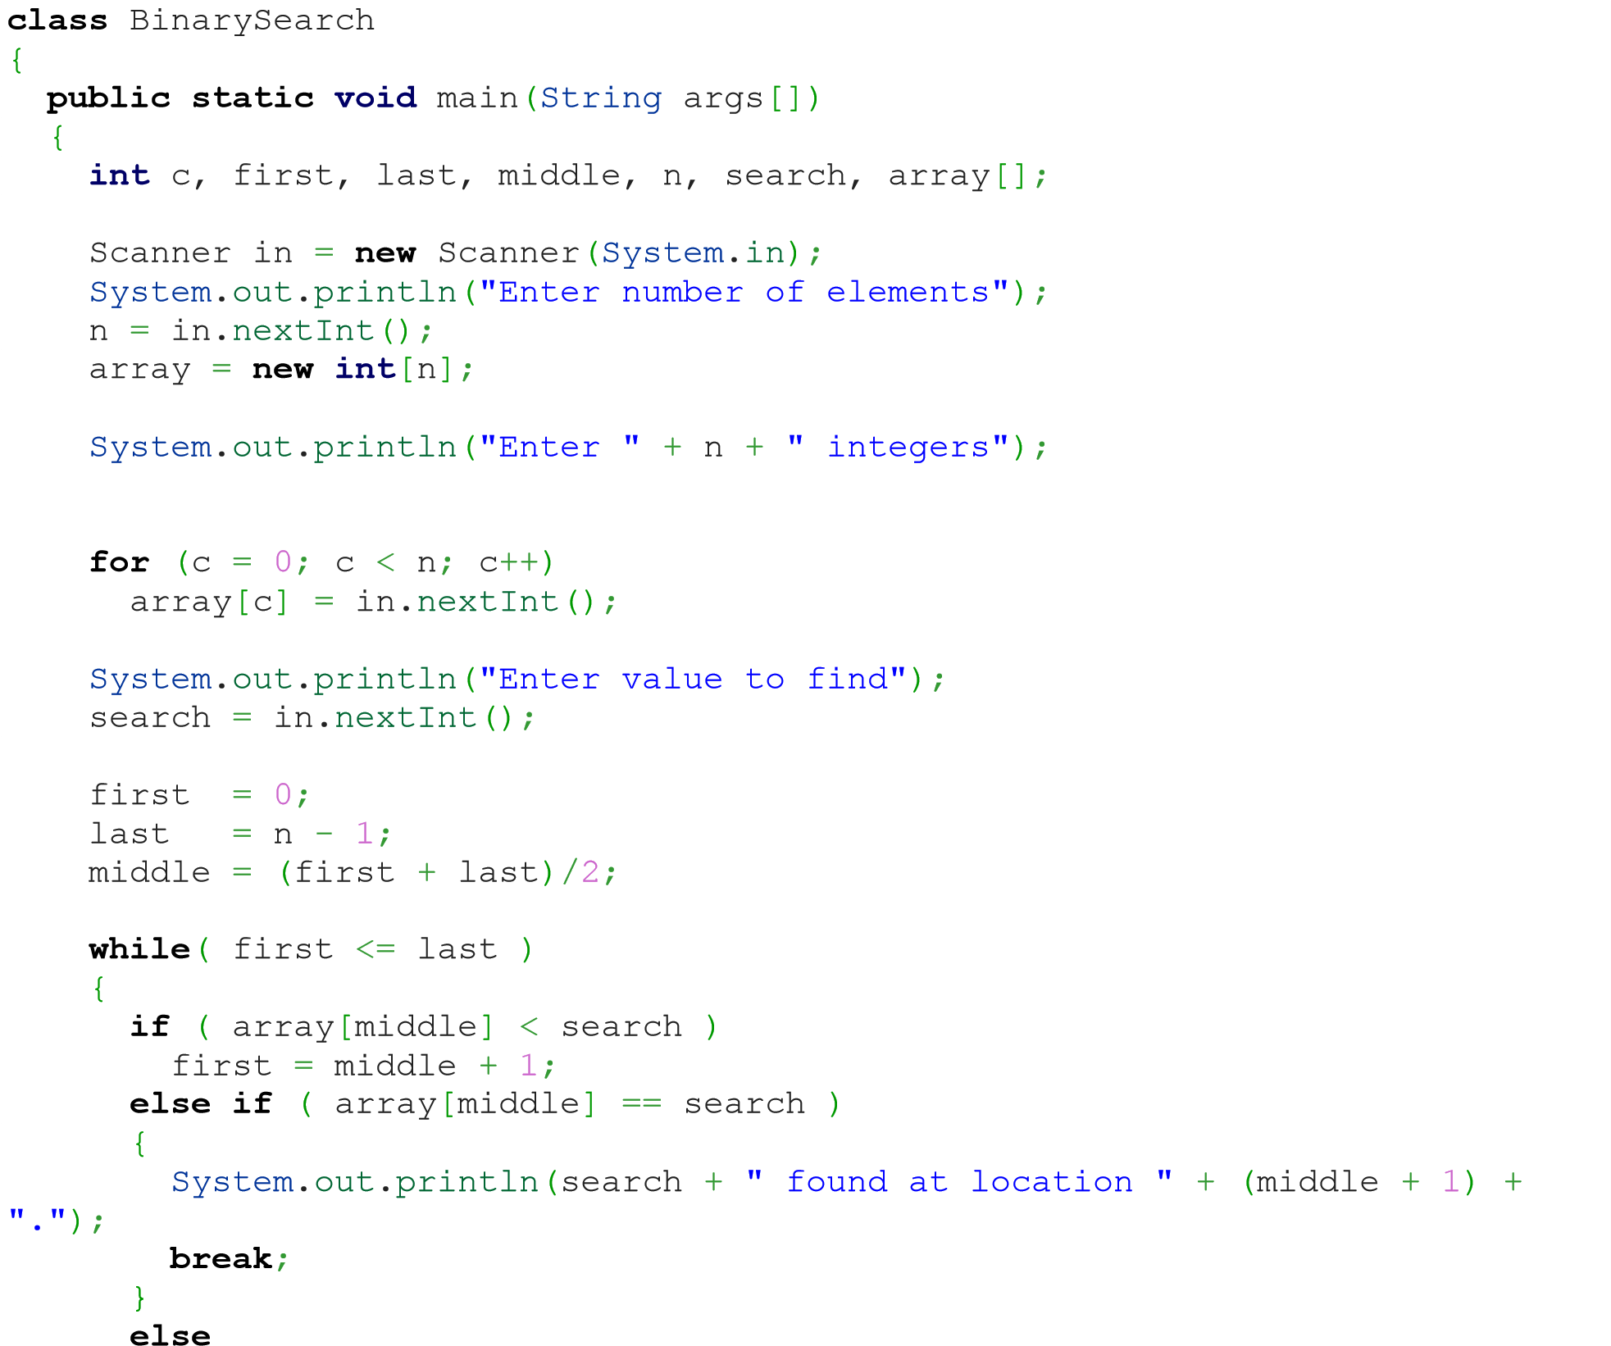
last = middle - 1;
middle = (first + last)/2;
}
if ( first > last )
System.out.println(search + " is not present in the list.\n"); }
}

Automation Pro ficient

62. Bubble sort Program in java
import java.util.Scanner;

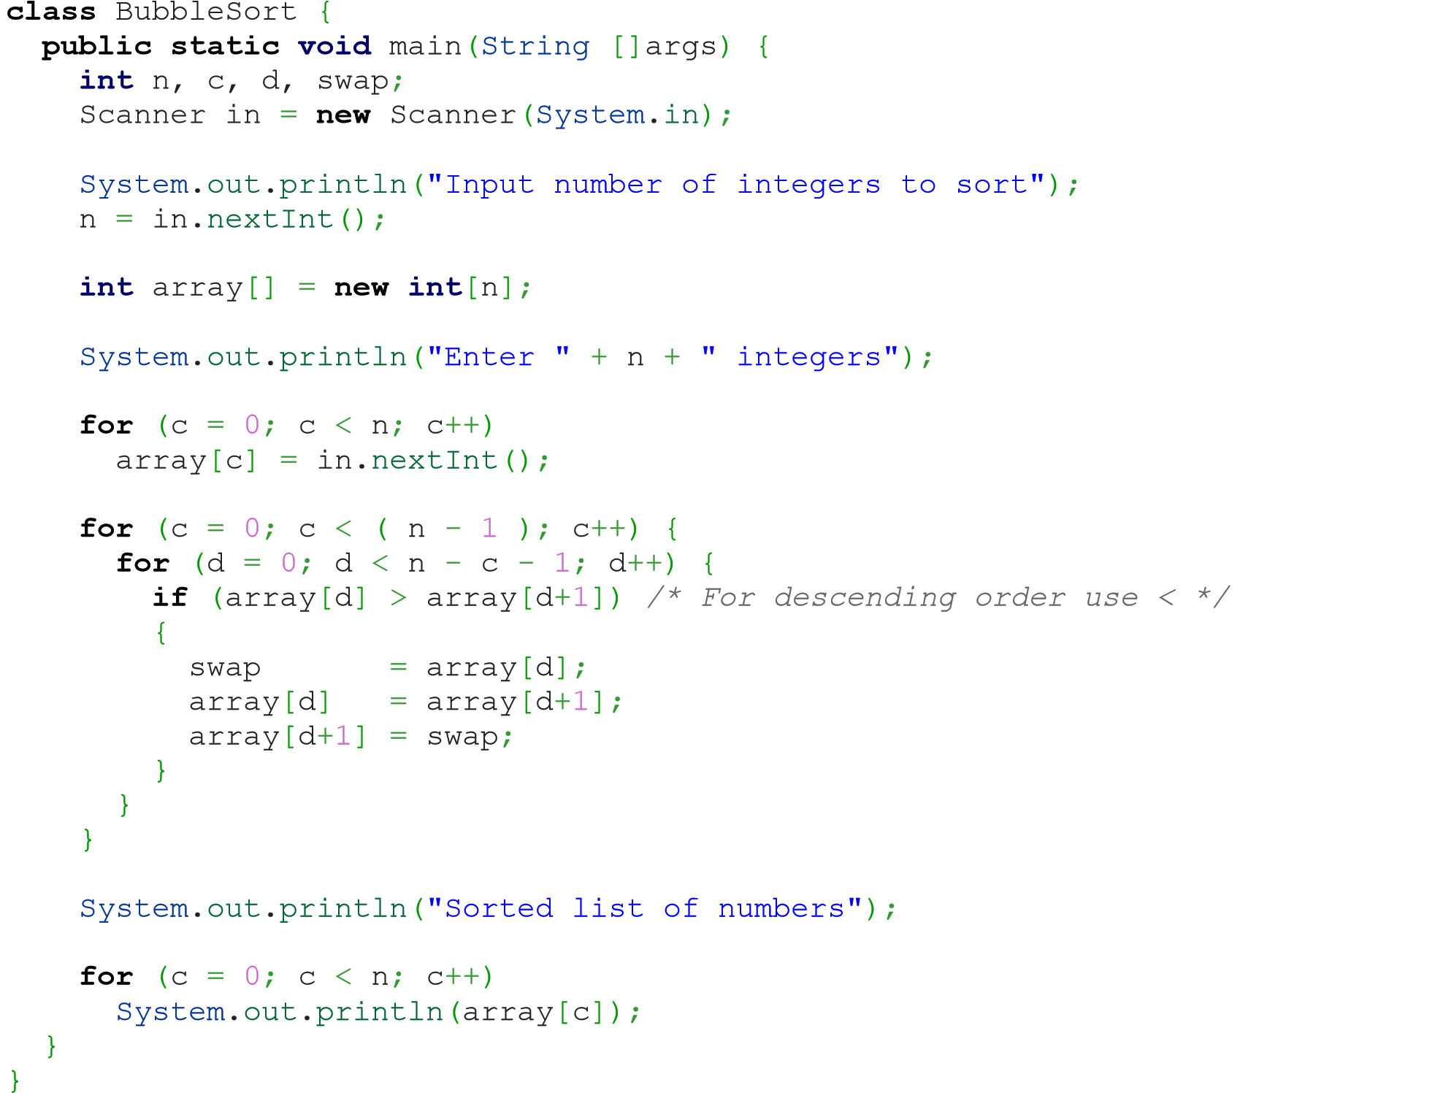

63. How to connect Database using java Program
import java.sql.*; class OracleCon{
public static void main(String args[]){ try{
//step1 load the driver class
Class.forName("oracle.jdbc.driver.OracleDriver");
//step2 create the connection object
Connection
con=DriverManager.getConnection("jdbc:oracle:thin:@localhost:1521:xe","system","oracl e");
//step3 create the statement object
Statement stmt=con.createStatement();
//step4 execute query
ResultSet rs=stmt.executeQuery("select * from emp"); while(rs.next())
System.out.println(rs.getInt(1)+" "+rs.getString(2)+" "+rs.getString(3));
//step5 close the connection object con.close();
}catch(Exception e){ System.out.println(e);}

}
}

64. How to insert data in table using JDBC in java Program
import java.sql.*; class InsertPrepared{
public static void main(String args[]){ try{
Class.forName("oracle.jdbc.driver.OracleDriver"); Connection
con=DriverManager.getConnection("jdbc:oracle:thin:@localhost:1521:xe","system","oracl e");
PreparedStatement stmt=con.prepareStatement("insert into Emp values(?,?)"); stmt.setInt(1,101);//1 specifies the first parameter in the query stmt.setString(2,"Ratan"); int i=stmt.executeUpdate();
System.out.println(i+" records inserted"); con.close();
}catch(Exception e){ System.out.println(e);}

}
}

65. How to insert image using JDBC in java Program
import java.sql.*; import java.io.*; public class InsertImage { public static void main(String[] args) { try{
Class.forName("oracle.jdbc.driver.OracleDriver");
Connection con=DriverManager.getConnection(
"jdbc:oracle:thin:@localhost:1521:xe","system","oracle");
PreparedStatement ps=con.prepareStatement("insert into imgtable values(?,?)");

Automation Proficient
ps.setString(1,"Technolamror");
FileInputStream fin=new FileInputStream("d:\\g.jpg"); ps.setBinaryStream(2,fin,fin.available()); int i=ps.executeUpdate();
System.out.println(i+" records affected"); con.close();
}catch (Exception e) {e.printStackTrace();}
}
}

66. How to execute Procedure in JDBC in java Program
import java.sql.*; public class Proc {
public static void main(String[] args) throws Exception{
Class.forName("oracle.jdbc.driver.OracleDriver"); Connection
con=DriverManager.getConnection("jdbc:oracle:thin:@localhost:1521:xe","system","oracl e");
CallableStatement stmt=con.prepareCall("{call insertR(?,?)}"); stmt.setInt(1,1011); stmt.setString(2,"Amit"); stmt.execute();
System.out.println("success");
}
}

67. How to check Regular expression in java Program
import java.util.regex.*; public class RegexExample1{
public static void main(String args[]){
//1st way
Pattern p = Pattern.compile(".s");//. represents single character
Matcher m = p.matcher("as"); boolean b = m.matches();
//2nd way
boolean b2=Pattern.compile(".s").matcher("as").matches();
//3rd way
boolean b3 = Pattern.matches(".s", "as");
System.out.println(b+" "+b2+" "+b3); }}

68. How to create Multithreading program in java
class Multi extends Thread{ public void run(){
System.out.println("thread is running...");
}
public static void main(String args[]){
Multi t1=new Multi(); t1.start();
} }

69. How to join thread in java program
class TestJoinMethod1 extends Thread{ public void run(){ for(int i=1;i<=5;i++){ try{
Thread.sleep(500);
}catch(Exception e){System.out.println(e);}
System.out.println(i);
} } public static void main(String args[]){ TestJoinMethod1 t1=new TestJoinMethod1();
TestJoinMethod1 t2=new TestJoinMethod1(); TestJoinMethod1 t3=new TestJoinMethod1(); t1.start(); try{ t1.join();
}catch(Exception e){System.out.println(e);}
t2.start(); t3.start();
}
}

70. How to write data in text file using java program
import java.io.FileOutputStream; public class FileOutputStreamExample { public static void main(String args[]){ try{
FileOutputStream fout=new FileOutputStream("D:\\testout.txt"); fout.write(65); fout.close();
System.out.println("success.. by Technolamror.");
}catch(Exception e){System.out.println(e);}
}
}

71. How to read data from text file using java program
import java.io.FileInputStream; public class DataStreamExample {

public static void main(String args[]){
try{
FileInputStream fin=new FileInputStream("D:\\Technolamror.txt"); int i=fin.read();
System.out.print((char)i);

fin.close();
}catch(Exception e){System.out.println(e);}
} }

72. How to get URL of site using java Programs
import java.io.*; import java.net.*; public class URLDemo{
public static void main(String[] args){ try{
URL url=new URL("http://www.technolamror.com/java");
System.out.println("Protocol: "+url.getProtocol());
System.out.println("Host Name: "+url.getHost());
System.out.println("Port Number: "+url.getPort());
System.out.println("File Name: "+url.getFile());

}catch(Exception e){System.out.println(e);}
}
}

73. How to get IP address from site URL using java program
import java.io.*; import java.net.*; public class InetDemo{
public static void main(String[] args){ try{
InetAddress ip=InetAddress.getByName("www.Technolamror.com");

System.out.println("Host Name: "+ip.getHostName());
System.out.println("IP Address: "+ip.getHostAddress());
}catch(Exception e){System.out.println(e);}
} }

74. How to create AWT program in java
import java.awt.*; class First extends Frame{
First(){
Button b=new Button("click me");
b.setBounds(30,100,80,30);// setting button position
add(b);//adding button into frame
setSize(300,300);//frame size 300 width and 300 height setLayout(null);//no layout manager
setVisible(true);//now frame will be visible, by default not visible
} public static void main(String args[]){
}} First f=new First();

75. How to add lable in AWT program in java
import java.awt.*; class LabelExample{
public static void main(String args[]){
Frame f= new Frame("Label Example by Technolamror"); Label l1,l2;
l1=new Label("First Label."); l1.setBounds(50,100, 100,30); l2=new Label("Second Label."); l2.setBounds(50,150, 100,30);
f.add(l1); f.add(l2);
f.setSize(400,400);
f.setLayout(null);
f.setVisible(true);
} }

76. How to add text area program in java
import java.awt.*; public class TextAreaExample
{
TextAreaExample(){
Frame f= new Frame();
TextArea area=new TextArea("Welcome to Technolamror"); area.setBounds(10,30, 300,300);
f.add(area);
f.setSize(400,400);
f.setLayout(null);
f.setVisible(true); }
public static void main(String args[])
{
new TextAreaExample();
}
}

77. How to dropdown in AWT program in java
import java.awt.*; public class ChoiceExample
{
ChoiceExample(){
Frame f= new Frame(); Choice c=new Choice();
c.setBounds(100,100, 75,75);
c.add("Item 1 by Rajendra");
c.add("Item 2 by Lamror");
c.add("Item 3 by Technolamror");
c.add("Item 4");
c.add("Item 5");
f.add(c);
f.setSize(400,400);
f.setLayout(null);
f.setVisible(true); }
public static void main(String args[])
{
new ChoiceExample();
}
}

78. How to create Swing program in java
import javax.swing.*; public class FirstSwingExample { public static void main(String[] args) {
JFrame f=new JFrame();//creating instance of JFrame JButton b=new JButton("click");//creating instance of JButton
b.setBounds(130,100,100, 40);//x axis, y axis, width, height
f.add(b);//adding button in JFrame
f.setSize(400,500);//400 width and 500 height
f.setLayout(null);//using no layout managers
f.setVisible(true);//making the frame visible
}
}

79. How to add checkbox in Swing program in java
import javax.swing.*; public class CheckBoxExample
{
CheckBoxExample(){
JFrame f= new JFrame("CheckBox Example by Technolamror");
JCheckBox checkBox1 = new JCheckBox("C++"); checkBox1.setBounds(100,100, 50,50);
JCheckBox checkBox2 = new JCheckBox("Java", true); checkBox2.setBounds(100,150, 50,50);
f.add(checkBox1);
f.add(checkBox2);
f.setSize(400,400);
f.setLayout(null);
f.setVisible(true); }
public static void main(String args[])
{ }} new CheckBoxExample();

80. How to convert string to integer in java program
public class StringToIntExample{ public static void main(String args[]){ String s="200";
int i=Integer.parseInt(s);
System.out.println(s+100);//200100 because + is string concatenation operator
}} System.out.println(i+100);//300 because + is binary plus operator

81. How to convert integer to string in java program
public class IntToStringExample1{ public static void main(String args[]){
int i=200;
String s=String.valueOf(i);
System.out.println(i+100);//300 because + is binary plus operator
}} System.out.println(s+100);//200100 because + is string concatenation operator

82. How to convert string to long in java
public class StringToLongExample{ public static void main(String args[]){ String s="9990449935"; long l=Long.parseLong(s);
}} System.out.println(l);

83. How to convert string to float in java
public class StringToFloatExample{ public static void main(String args[]){ String s="23.6";
float f=Float.parseFloat("23.6");
}} System.out.println(f);

84. How to convert string to double in java program
public class StringToDoubleExample{
public static void main(String args[]){

String s="23.6";
double d=Double.parseDouble("23.6");

System.out.println(d); ;

}

}

85. How to convert string to date in java program
import java.text.SimpleDateFormat; import java.util.Date; public class StringToDateExample1 {
public static void main(String[] args)throws Exception {
String sDate1="31/12/1998";
String sDate2 = "31-Dec-1998";
String sDate3 = "12 31, 1998";
String sDate4 = "Thu, Dec 31 1998";
String sDate5 = "Thu, Dec 31 1998 23:37:50";
String sDate6 = "31-Dec-1998 23:37:50";
SimpleDateFormat formatter1=new SimpleDateFormat("dd/MM/yyyy");
SimpleDateFormat formatter2=new SimpleDateFormat("dd-MMM-yyyy");
SimpleDateFormat formatter3=new SimpleDateFormat("MM dd, yyyy");
SimpleDateFormat formatter4=new SimpleDateFormat("E, MMM dd yyyy");
SimpleDateFormat formatter5=new SimpleDateFormat("E, MMM dd yyyy HH:mm:ss");
SimpleDateFormat formatter6=new SimpleDateFormat("dd-MMM-yyyy HH:mm:ss");
Date date1=formatter1.parse(sDate1);
Date date2=formatter2.parse(sDate2);
Date date3=formatter3.parse(sDate3);
Date date4=formatter4.parse(sDate4);
Date date5=formatter5.parse(sDate5);
Date date6=formatter6.parse(sDate6);
System.out.println("String to Date converter by technolamror");
System.out.println(sDate1+"\t"+date1);
System.out.println(sDate2+"\t"+date2);
System.out.println(sDate3+"\t"+date3);
System.out.println(sDate4+"\t"+date4);
System.out.println(sDate5+"\t"+date5);
System.out.println(sDate6+"\t"+date6);
}
}

86. Create ArrayList program in java
import java.util.*; class Arrylist_Technolamror{
public static void main(String args[]){
ArrayList<String> list=new ArrayList<String>();//Creating arraylist list.add("Rajendra");//Adding object in arraylist list.add("Mahendra"); list.add("Raja"); list.add("Technolamror");
//Traversing list through Iterator Iterator itr=list.iterator(); while(itr.hasNext()){
System.out.println(itr.next()); }
}
}

87. How to create LinkedList program in java
import java.util.*;
public class LinkedList_technolamror{ public static void main(String args[]){

Linkedal<String> al=new Linkedal<String>();

al.add("Rajendra");//Adding object in LinkedList al.add("Mahendra"); al.add("Raja"); al.add("Technolamror");

Iterator<String> itr=al.iterator(); while(itr.hasNext()){
System.out.println(itr.next()); }
}
}

88. How to ArrayList using list interface program in java
import java.util.*; class Book { int id;
String name,author,publisher; int quantity;
public Book(int id, String name, String author, String publisher, int quantity) { this.id = id; this.name = name; this.author = author; this.publisher = publisher; this.quantity = quantity;
} } public class ListIteratorExample { public static void main(String[] args) {
//Creating list of Books
List<Book> list=new ArrayList<Book>();
//Creating Books
Book b1=new Book(101,"Let us C","Yashwant Kanetkar","BPB",8);
Book b2=new Book(102,"Java Program Questation","Rajendra","Technolamror",4);
Book b3=new Book(103,"Operating System","Galvin","Wiley",6);
//Adding Books to list
list.add(b1); list.add(b2); list.add(b3);
System.out.println("Original content of list is: ");
//Traversing list for(Book b:list){
System.out.println(b.id+" "+b.name+" "+b.author+" "+b.publisher+" "+b.quantity); }
ListIterator<Book> itr=list.listIterator();
System.out.println("Modified content of list in backward is: "); while(itr.hasNext()){ Book st=(Book)itr.next();
System.out.println(st.quantity+" "+st.publisher+" "+st.author+" "+st.name+"
"+st.id);
}
}
}

89. How to create Hashset program in java
import java.util.*; class TestCollection9{
public static void main(String args[]){ //Creating HashSet and adding elements HashSet<String> set=new HashSet<String>(); set.add("Rajendra"); set.add("Raja"); set.add("Ravi"); set.add("Technolamror");
//Traversing elements
Iterator<String> itr=set.iterator(); while(itr.hasNext()){
System.out.println(itr.next()); }
}
}

90. How to create LinkedHashSet program in java
import java.util.*;
class LinkedHashSet_Technolamror{ public static void main(String args[]){
LinkedHashSet<String> al=new LinkedHashSet<String>();

al.add("Rajendra"); al.add("Raja"); al.add("Ravi"); al.add("Technolamror");

Iterator<String> itr=al.iterator(); while(itr.hasNext()){
out itr
}
}
}

91. How to create TreeSet program in java
import java.util.*; class TreeSet_Technolamror{
public static void main(String args[]){ //Creating and adding elements
TreeSet<String> al=new TreeSet<String>(); al.add("Rajendra"); al.add("Raja"); al.add("Ravi");
al.add("Technolamror"); ments Iterator<String> itr=al.iterator(); while(itr.hasNext()){
System.out.println(itr.next()); }
}
}

92. How to create PriorityQueue program in java
import java.util.*; class PriorityQueue_Technolamror{ public static void main(String args[]){
PriorityQueue<String> queue=new PriorityQueue<String>(); queue.add("Rajendra"); queue.add("Mahendra"); queue.add("Raja"); queue.add("Technolamror"); queue.add("Rahul");
System.out.println("head:"+queue.element());
System.out.println("head:"+queue.peek());
System.out.println("iterating the queue elements:");
Iterator itr=queue.iterator(); while(itr.hasNext()){
System.out.println(itr.next());
} queue.remove(); queue.poll();
System.out.println("after removing two elements:");
Iterator<String> itr2=queue.iterator();
while(itr2.hasNext()){
System.out.println(itr2.next());
}
}
}

93. How to create HashMap using map interface program in java
import java.util.*; class MapInterfaceExample{
public static void main(String args[]){
Map<Integer,String> map=new HashMap<Integer,String>(); map.put(100,"Rajendra"); map.put(101,"Lamror"); map.put(102,"Technolamror"); for(Map.Entry m:map.entrySet()){
System.out.println(m.getKey()+" "+m.getValue()); }
}
}

94. How to create LinkedHashMap program in java
import java.util.*; class LinkedHashMap_Technolmaror{ public static void main(String args[]){

LinkedHashMap<Integer,String> hm=new LinkedHashMap<Integer,String>();

hm.put(100,"Rajendra"); hm.put(101,"Vijay"); hm.put(102,"Technolamror");

for(Map.Entry m:hm.entrySet()){
System.out.println(m.getKey()+" "+m.getValue()); }
}
}

95. How to create TreeMap program in java
import java.util.*; class TreeMap_Technolamror{
public static void main(String args[]){
TreeMap<Integer,String> hm=new TreeMap<Integer,String>(); hm.put(100,"Amit"); hm.put(102,"Ravi"); hm.put(101,"Vijay"); hm.put(103,"Technolamror"); for(Map.Entry m:hm.entrySet()){
System.out.println(m.getKey()+" "+m.getValue());
}
}
}

96. How to create Hashtable program in java
import java.util.*; class Hashtable_Technolamror{ public static void main(String args[]){
Hashtable<Integer,String> hm=new Hashtable<Integer,String>();

hm.put(100,"Rajendra"); hm.put(102,"Praveen"); hm.put(101,"Bipin"); hm.put(103,"Pankaj");

for(Map.Entry m:hm.entrySet()){
System.out.println(m.getKey()+" "+m.getValue()); }
}
}

97. How to create Array program in java
class Array_Technolamror{
public static void main(String args[]){

int a[]=new int[5];//declaration and instantiation a[0]=10;//initialization a[1]=20; a[2]=70; a[3]=40; a[4]=50;

//printing array
for(int i=0;i<a.length;i++)//length is the property of array System.out.println(a[i]);
}}

98. How to create Multidimensional array program in java
class Multi_Array{
public static void main(String args[]){

//declaring and initializing 2D array int arr[][]={{1,2,3},{2,4,5},{4,4,5}};

//printing 2D array for(int i=0;i<3;i++){ for(int j=0;j<3;j++){
System.out.print(arr[i][j]+" ");
}
System.out.println();
}

}}

99. How to create Find Factorial No using Recursion Program in java

public class Recursion_Technolamror { static int factorial(int n){ if (n == 1) return 1; else
return(n * factorial(n-1));
}
public static void main(String[] args) {
System.out.println("Factorial of 5 is: "+factorial(5));
} }

100. How to create Method Overriding program in java
class Bank{
int getRateOfInterest(){return 0;}
}
class SBI extends Bank{ int getRateOfInterest(){return 8;}
}
class ICICI extends Bank{ int getRateOfInterest(){return 7;}
}
class AXIS extends Bank{ int getRateOfInterest(){return 9;}
} class Test2{
public static void main(String args[]){
SBI s=new SBI();
ICICI i=new ICICI();
AXIS a=new AXIS();
System.out.println("SBI Rate of Interest: "+s.getRateOfInterest());
System.out.println("ICICI Rate of Interest: "+i.getRateOfInterest());
System.out.println("AXIS Rate of Interest: "+a.getRateOfInterest()); } }

